**Screen Capture:**

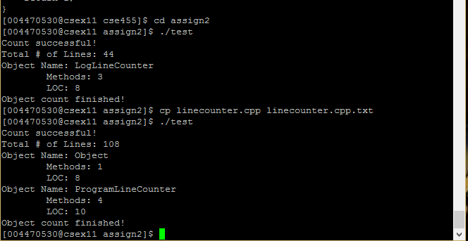

**Class Diagram:**

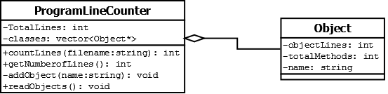

**Assignment # 2 Output Table:**

|  |  |  |  |  |
| --- | --- | --- | --- | --- |
| **Program Number** | **Object Name** | **Number of Methods** | **Object LOC** | **Total LOC** |
| Assign -1 | LogLineCounter | 3 | 8 |  |
|  |  |  |  | 44 |
| Assign -2 | ProgramLineCounter | 4 | 10 |  |
|  | Object | 1 | 8 |  |
|  |  |  |  | 108 |